Improving learning rates on standardised testing through a balanced teaching cycle: a tale of three schools
Tierney Kennedy

Introduction
Media articles often portray instructivist and constructivist approaches pitted against each other, promoting “maths wars” and failing to reflect a balanced approach (Abtahi and Barwell, 2022).
This either-or debate fails to reflect research and classroom findings – that both approaches have their merits and both also have their problems. As Hattie recently stated in an article on Visible Learning: the sequel,

“So many debates about curriculum and learning outcomes are phrased as either more “knowledge-rich” (teaching content) or more “problem-based discovery learning” (teaching how to discover ideas). But it is not a question of either/or. We need to be greedy and want both.” (Hattie, 2023)

This article presents the results from a longitudinal study of three schools in South Australia who chose to implement a balanced teaching-learning cycle. By the third year of implementation, growth rates on PAT Maths testing had increased by 75% from their 2018 baseline rates (n=610 students).

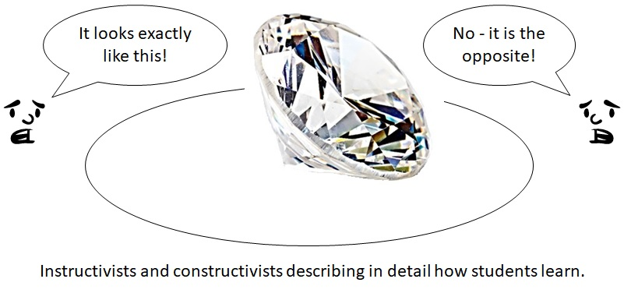

Short literature summary of instructivist and constructivist approaches

Instructivist-based research emphasises high impacts on standardised-testing results; as well as arguing that the approaches tend to be easy it is for teachers to implement with fidelity (Ellis, 2005; Ewing, 2011; Farkota, 2013; Kirschner et. al, 2006). In particular, instructivist approaches have been shown to have high impacts on students identified as at-risk of school failure (Adams & Engelmann, 1996; Ellis, 2005). Criticisms of instructivist approaches centre on the emphasis of procedures over conceptual understanding (Cooney, 2001; D'Ambrosio & Harkness, 2004; Wood & Doan, 2006); little or no practice at solving mathematical problems (Schoenfeld, 1994); and minimal opportunities for constructing an identity as a successful mathematics learner (D'Ambrosio & Harkness, 2004).

Constructivist-based research argues that solving challenging problems supports conceptual thinking and produces greater overall learning gains than instructivist approaches (Boaler & Staples, 2008; Rakes et. al, 2010; Stein & Lane, 1996). In particular, the use of challenging tasks to introduce new mathematical concepts is argued generate higher levels of engagement (Sullivan et al., 2015), facilitate opportunities for reasoning and creative thinking (Stein & Lane, 1996; Sullivan & Davidson, 2014), improve persistence (Sullivan et al., 2014) and result in faster learning gains (Rakes et al., 2010). Criticisms of constructivist approaches centre on the idea that minimally guided instruction ignores the “structures, functions, and characteristics of working and long-term memory” (Kirschner et. al, 2006, p.77), that when students are provided with minimal feedback they often become lost and frustrated leading to misconceptions (Brown and Campione, 1994), and that that because false starts are common learning is often inefficient (Carlson, Lundy, & Schneider, 1992).

A third approach, Conceptual Change Programs, emphasises the need for change or growth at the conceptual level for learning to occur (Carey, 1985; 1986; Posner et al.,1982; Strike & Posner, 1985, 1992). This centres around the idea of motivating learners to change their own ideas or beliefs (Mayer, 2008; Posner et al., 1982; Resnick, 1983). In science, this typically involves using an experimental problem paired with discrepant events and questioning (Erilymaz, 2002; Swan, 2001) to create cognitive conflict (Posner et al., 1982; Resnick, 1983) whereby a learner recognizes an anomaly in their own thinking and then actively constructs a new model that explains the observable facts (Mayer, 2008). In mathematics classrooms, the approach tends to involve the juxtaposition of discrepant events and questioning to address student conceptions (see Askew and Wiliam, 1995; Kennedy, 2015a; Swan, 2001; Swan, 2005). A strong body of research shows very high impacts in science (Hattie, 2015). Some research also exists showing strong growth rates and results for low-performing students in mathematics (Kennedy, 2018; Swan, 2001, 2005), however very little mathematics research has focused on students at other levels.

Background information on this study and the implementation strategy
All teachers and students from three South Australian primary schools took part in the study between 2019 and 2021. Two schools were urban and one was rural. All three schools sent small team of teachers to a training project with the author in 2018, then elected to continue the project across all classes at the start of 2019. The different teaching lessons were introduced gradually, with an initial focus on experimental problems and conceptual change questioning as teachers were more familiar with explicit teaching.

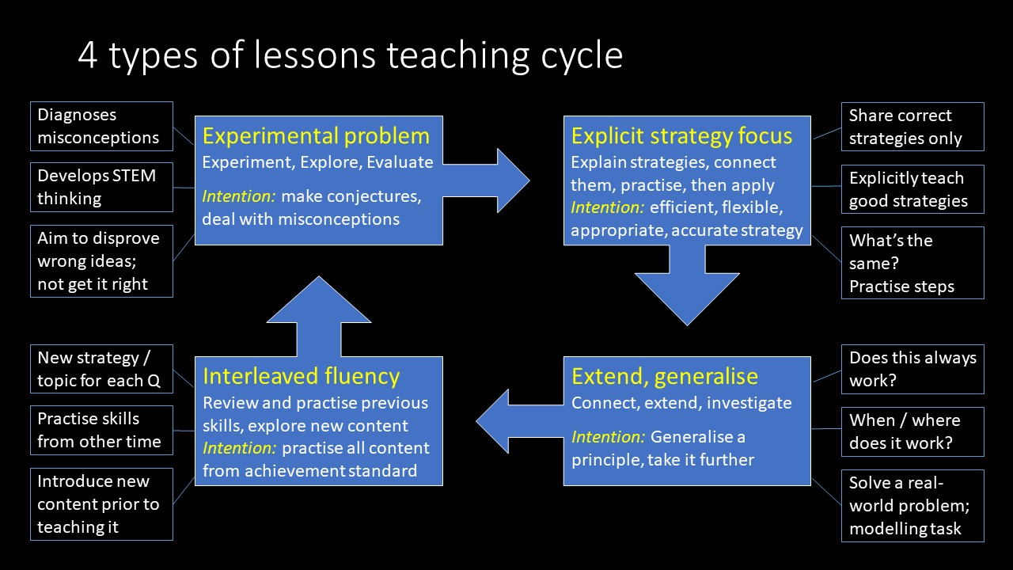

The teaching-learning cycle
The approach implemented by teachers involved implementing different types of lessons to achieve different purposes. The diagram below illustrates the overall process, with descriptions to follow.

Experimental Problem
Each cycle began with an experimental problem – an unfamiliar or non-routine problem that was explored by students prior to formal explanation based on the Launch, Explore, Summarise model (Lappan et al., 2006). These problems acted as formative assessment for illustrating misconceptions. Using these problems at the start of a teaching cycle allowed subsequent lessons to be more targeted.
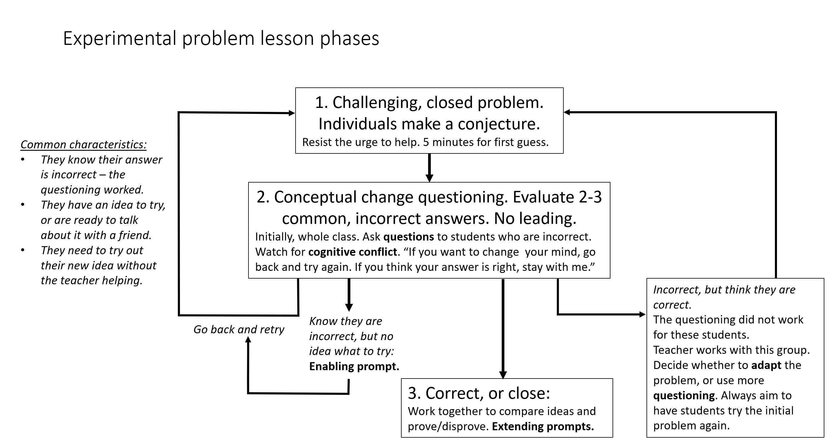

Experimental lessons began with a challenging, but closed problem, enabling teachers to quickly determine whether ideas were correct or incorrect and addressing teachers’ difficulties with identifying misconceptions (Son & Kim, 2015). Students made conjectures about possible answers, then started on the process of trying out their ideas. Teachers aimed for roughly 80% of initial conjectures to be incorrect.

Within five minutes, the teacher gathered the whole class back together for an evaluation of initial conjectures. During this session, the teacher focused incorrect ideas that were shared by multiple students. The teacher posed questions that encouraged students to test out their conjecture, rather than attempting to lead students towards a different answer. They watched student body language, looking for evidence of cognitive conflict or surprise that would indicate that the student realised their idea had not worked.

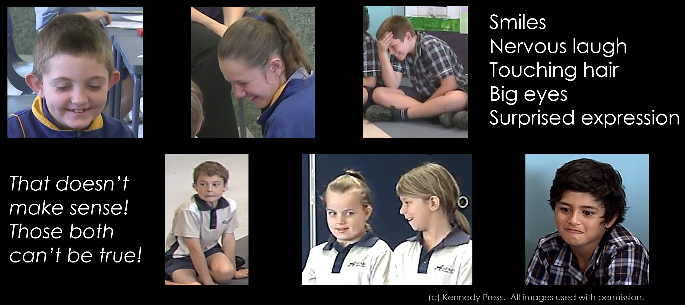
At that point, students could elect to go back and change their minds, or to stay with the teacher if they thought their ideas were correct. Students who went back to have a second try worked together to try and solve the problem. Students who stayed with the teacher were divided into two groups: those who were correct (or close to correct), and those whose ideas were incorrect but thought they were correct. The teacher challenged the students who were correct-or-close to compare answers and prove that their ideas worked. They were provided with extending prompts (Sullivan et al, 2009) to work on together. Students who were incorrect worked with the teacher, who provided additional questioning and adapted the question as needed.

If the majority of students solved the problem, the teacher provided a simple summary and then challenged students with a more difficult problem. However, where students had not solved the problem teachers were encouraged to delay providing a solution until the next day. While this initially proved difficult as students were frustrated, teachers noted that students were far more engaged in the solution by the next lesson and a number had continued to think about it overnight. Within 6-8 weeks, the culture of the classes changed and both students and teachers became more comfortable with this process.

At the end of each lesson, teachers recorded some simple observations to help them make the best use of the following lessons:
B: Best thinking – jot initials of students who have done some of their best thinking
P: Passengers – jot initials of students who were just “along for the ride”
N: Next – jot one “next action” to take following the lesson (e.g., share a student’s strategy, build in an explanation using a particular idea, use a specific follow-up question, build the concept into a specific area of maths).

Explicit Strategy Focus
The follow up lesson involved summarising any solutions students had found, then explicitly teaching strategies and practising skills, somewhat similar to the summary phase of the Launch-Explore-Summarise Framework (Lappan et al., 2006). Teachers began by asking selected students who had successfully solved the problem to share their strategies with the class. Only good strategies were selected for whole-class sharing, after which the teacher re-explained the strategy to students, illustrating each step. The teacher could also elect to share another strategy with the class if helpful, or stick with the student-generated strategy. When possible, strategies were named after the students who developed them. Where multiple good strategies were shared, the class compared the strategies to find the mathematical similarities between them, and focus on the essential steps. At this point, teachers provided some practise questions and further extension.

While full lesson plans were not provided for these lessons as teachers were mostly familiar with the approach, guidance on appropriate strategies and key concepts was supplied during professional learning times.

Extend and Generalise
A third type of lesson focused on the patterns, extending a strategy to more complex questions and generalising rules. Questions often required students to manipulate their strategy, working backwards or filling a gap in an unusual position in an equation. They focused on identifying patterns, creating rules, adapting the rules to more complex questions and establishing principles that could be transferred to related contexts.

Interleaved and Spaced Fluency for Retrieval
In the third year of each project, teachers were introduced to the work of Bjork and Bjork on the theory of disuse (1992) and Roher et. al on interleaved practise (2019). A fourth type of lesson was introduced to focus on developing retrieval skills and increasing retention over time. During this lesson, students worked with a partner through a set of interleaved and spaced questions. Answers to the questions were provided to students, acting as an enabling prompt and encouraging them to try the more difficult questions together. Throughout the session, teachers did not help students with the questions, but instead worked with small groups or individuals for short amounts of time as needed (e.g., worked with students identified as “passengers” in the experimental problem, checked in with students requiring extension on their progress in investigations…). At the end of these sessions, students selected questions that they had struggled to solve for the teacher to review the next day.

Training and Resourcing
In 2019, each school undertook an initial student free day for training, then participated in 4-5 follow up sessions with smaller groups of teachers spread throughout the year. During the first six months, teachers trialled the experimental problem lesson, using specifically selected interventions lessons targeted at key number concepts (Kennedy, 2015b). The initial success of this trial built both skills and confidence, leading to adopting the balanced cycle for 2-3 lessons each week for the remainder of 2019. Each term, teachers were supported with in-person and online sessions along with resources to adapt for their class. During 2020, teachers continued to implement the approach, with support each term through professional learning. In 2021, PL was cut back to a single day each semester, with a focus on interleaved and spaced practise. On average, this added up to 20 hours of professional learning per teacher, spread over the three years.

In addition to the interventions lessons, teachers were provided with a set of adaptable lesson plans for ACv8 (Kennedy, 2012) as a starting point for implementing the approach. Rather than requiring implementation with fidelity, teachers were encouraged to adapt the plans to suit their students, allowing for the complexities inherent in real school environments. They were also provided with a suggested work program that used just under 50% of their lessons, encouraging teachers to self-select or design additional lessons to respond to their students’ needs. These lessons were not planned until the content-teaching lessons were completed, allowing teachers to provide just-in-time intervention, support or extension as needed.

Results
PAT-M testing was selected for this study as it was readily available in each school, and provides objective and norm-referenced information on students’ level of achievement, their skills, and understanding of mathematics (Lindsey et al., 2005). Annual growth data from 2017-2018 provided a baseline for each year level (n=610 students in 2018). Data were only included if students completed PAT-M testing in two adjacent years. Student growth rates for each year level during 2018 was compared with student growth for each year level during 2021 (n=622 students in 2021).
On average, growth rates increased by 75%.

Year (no. students) | Pre-test mean | Post-test mean | Growth
2018 (610) | 116.1 | 120.1 | 4.0
2021 (622) | 117.7 | 124.7 | 7.0

Each year level’s growth was also compared to the 50th percentile figures published by ACER. The graph and table that follow show the growth rate expressed in years, compared to those figures.

Year level | 2018 growth in years compared to the 50th percentile | 2021 growth in years compared to the 50th percentile | Increase in growth rate (in years)
Year 3 | 1.2 | 1.1 | -0.1
Year 4 | 0.8 | 1.4 | 0.7
Year 5 | 0.3 | 1.2 | 0.9
Year 6 | 1.2 | 2.8 | 1.6
Year 7 | -0.2 | 2.2 | 2.4

All year levels, with the exception of year 3, increased their growth rates by at least 0.7 years. In 2021, all year levels were growing at a higher rate than the 50th percentile rate.

Tracked students
Results could be tracked from 2018-2021 for 80 year 7 students and 93 year 6 students. Year 7 tracked results showed that students increased from the 53rd percentile in 2018 to the 70th percentile in 2021. Year 6 tracked students increased from the 53rd percentile to the 73rd percentile.

Discussion and Conclusion
Over the course of the three year project, the rate of growth on standardised testing increased by 75%. Students who were at the school for four successive PAT tests achieved at around 20 percentile points higher, indicating a significant rate of improvement. These results indicate that explicit and problem-based approaches can be used in a complementary manner, creating a balanced teaching cycle, and with significant potential to improve the rate at which students learn mathematics.

References:
Abtahi, Yasmine & Barwell, Richard. (2020). Who are the actors and who are the acted-ons? An analysis of news media reporting on mathematics education. Mathematics Education Research Journal. 34. 10.1007/s13394-020-00358-3.
Adams, G., & Engelmann, S. (1996). Research on direct instruction: 25 years beyond. DISTAR. Seattle: Educational Achievement System.
Askew, M., Brown, M., Rhodes, V., Johnson, D., and William, D. (1997). Effective teachers of numeracy. Final report. London: King’s College.
Askew, M. and Wiliam, D. (1995) Recent Research in Mathematics Education 5–16: OFSTED Reviews of Research, London: HMSO.
Bjork, R. A., & Bjork, E. L. (1992). A new theory of disuse and an old theory of stimulus fluctuation. In A. F. Healy, S. M. Kosslyn, & R. M. Shiffrin (Eds.), From Learning Processes to Cognitive Processes: Essays in Honor of William K. Estes, (Vol. 2, pp. 35-67). Hillsdale, NJ: Erlbaum.
Boaler, J., and Staples, M. (2008). Creating mathematical futures through an equitable teaching approach: the case of railside school. Teachers College Record, 110(3), 608-645.
Brown, A., & Campione, J. (1994). Guided discovery in a community of learners. In K. McGilly (Ed.), Classroom lessons: Integrating cognitive theory and classroom practice (pp. 229–270). Cambridge, MA: MIT Press.
Carey, S. (1985). Conceptual change in childhood. Cambridge, MA: MIT Press.
Carey, S. (1986). Cognitive science and science education. American Psychologist, 41, 1123-1130.
Carlson, R. A., Lundy,D.H.,&Schneider,W. (1992). Strategy guidance and memory aiding in learning a problem-solving skill. Human Factors, 34, 129–145.
Cooney, T. (2001). Considering the paradoxes, perils, and purposes of conceptualizing teacher development. In F. Lin, and, T. Cooney (Eds.), Making sense of mathematics teacher education (pp. 9-32). Dordrecht: Kluwer Academic Publishers.
D'Ambrosio, B., & Harkness, S. (2004). Planning district-wide professional development: Insights gained from teachers and students regarding mathematics teaching in a large urban district. School Science and Mathematics, 104(1), 5-15.
Ellis, L. (2005). Balancing approaches: Revisiting the educational psychology research on teaching students with learning difficulties. Retrieved, from http://www.acer.edu.au/documents/AER_48-BalancingApproaches.pdf
Eryilmaz, A. (2002). Effects of conceptual assignments and conceptual change discussions on students’ misconceptions and achievement regarding force and motion. Journal of Research in Science Teaching, 39 (10), pp.1001-1015.
Ewing, B. (2011). Direct instruction in mathematics: issues for schools with high indigenous enrolments: a literature review. Australian Journal of Research Education, 36 (5), pp.65-92.
Farkota, R. (2003). The effects of a 15-minute direct instruction intervention in the regular mathematics class on students' mathematics self-efficacy and achievement. Melbourne: Faculty of Education, Monash University. Retrieved from http://www.acer.edu.au/documents/FarkotaThesis.pdf
Hattie, J. (2015). The Applicability of Visible Learning to Higher Education. Scholarship of Teaching and Learning in Psychology; American Psychological Association, 2015, 1(1), 79–91. Downloaded from result.uit.no/basiskompetanse/wp-content/uploads/sites/29/2016/07/Hattie.pdf
Hattie, J. (2023). Education expert John Hattie’s new book draws on more than 130,000 studies to find out what helps students learn. The Conversation: https://theconversation.com/education-expert-john-hatties-new-book-draws-on-more-than-130-000-studies-to-find-out-what-helps-students-learn-201952
Kennedy, T. (2012) Back to Front Maths series. Website: www.backtofrontmaths.com.au
Kennedy, T. (2015a). Addressing Alternative Conceptions in Mathematics Using Discrepant Events. In Mathematics: Learn, Lead, Link (Proceedings of the 25th biennial conference of the Australian Association of Mathematics Teachers, pp. 71-78). Adelaide: AAMT.
Kennedy, T. (2015b) Interventions in Mathematics Series. Townsville: Kennedy Press.
Kennedy, T. (2018). Effectiveness of Applying Conceptual Change Approaches in Challenging Mathematics Tasks for Low-Performing Students. In Hunter, J., Perger, P., & Darragh, L. (Eds.). Making waves, opening spaces (Proceedings of the 41st annual conference of the Mathematics Education Research Group of Australasia) pp. 447-454. Auckland: MERGA.
Kirschner, P., Sweller, J., and Clark, R. (2006). Why Minimal Guidance During Instruction Does Not Work: An Analysis of the Failure of Constructivist, Discovery, Problem-Based, Experiential, and Inquiry-Based Teaching, Educational Psychologist, 41:2, 75-86, DOI: 10.1207/s15326985ep4102_1
Lappan, G., Fey, J., Fitzgerald, W., Friel, S. and Phillips, E. (2006). Connected Mathematics 2. Pearson, Prentice, Hall.
Lindsey, J., Stephanou, A., Urbach, D., and Sadler, A. (2005). PAT Maths Progressive Achievement Tests in Mathematics Third Edition Teacher Manual. Camberwell, Australia: Australian Council for Educational Research
Mayer, R. E. (2008). Learning and instruction (2nd ed.) . Upper Saddle River, NJ: Pearson Education, Inc.
Posner, G. J., Strike, K. A., Hewson, P. W., and Gertzog, W. A. (1982). Accommodation of a scientific conception: Toward a theory of conceptual change. Science Education, 66(2), 211-227.
Rakes, C. R., Valentine, J. C., McGatha, M. B., & Ronau, R. N. (2010). Methods of Instructional Improvement in Algebra: A Systematic Review and Meta-Analysis. Review of Educational Research, 80(3), 372–400. https://doi.org/10.3102/0034654310374880
Resnick, L. B. (1983). Mathematics and science learning: A new conception. Science, 220, 477-478.
Rohrer, D., Dedrick, R. F., Hartwig, M. K., & Cheung, C.-N. (2020). A randomized controlled trial of interleaved mathematics practice. Journal of Educational Psychology, 112(1), 40–52. https://doi.org/10.1037/edu0000367
Schoenfeld, A. (1994). Reflections on doing and teaching mathematics. In A. Schoenfeld (Ed.), Mathematical thinking and problem solving (pp. 53-72). New Jersey: Lawrence Erlbaum Associates.
Son, J., and Kim, O. (2015). Teachers’ selection and enactment of mathematical problems from textbooks. Mathematics Education Research Journal, 27(4), 491-518.
Stein, M. K., and Lane, S. (1996). Instructional tasks and the development of student capacity to think and reason: an analysis of the relationship between teaching and learning in a reform mathematics project. Educational Research and Evaluation, 2, 50-80.
Strike, K. A., & Posner, G. J. (1985). A conceptual change view of learning and understanding. In L. H. T. West & A. L. Pines (Eds.), Cognitive structure and conceptual change. New York: Academic Press.
Sullivan, P., Mousley, J., & Jorgensen, R. (2009). Tasks and pedagogies that facilitate mathematical problem solving. In B. Kaur (Ed.), Mathematical problem solving (pp.17-42). Association of Mathematics Educators: Singapore / USA / UK World Scientific Publishing.
Sullivan, P., Clarke, D., Cheeseman, J., Mornane, A., Roche, A., Sawatzki, C. and Walker, N. (2014). Students’ Willingness to Engage with Mathematical Challenges: Implications for Classroom Pedagogies. In J. Anderson, M. Cavanagh and A. Prescott (Eds.). Curriculum in focus: Research guided practice (Proceedings of the 37th annual conference of the Mathematics Education Research Group of Australasia) pp. 597–604. Sydney: MERGA.
Sullivan, P. and Davidson, A. (2014). The Role of Challenging Mathematical Tasks in Creating Opportunities for Student Reasoning. In J. Anderson, M. Cavanagh & A. Prescott (Eds.). Curriculum in focus: Research guided practice (Proceedings of the 37th annual conference of the Mathematics Education Research Group of Australasia) pp. 605–612. Sydney: MERGA.
Swan, M. (2001). Dealing with misconceptions in mathematics. In P. Gates (Ed.) Issues in Mathematics Teaching (pp.147-165). London: RoutledgeFalmer.
Swan, M. (2005). Standards Unit Improving learning in mathematics: challenges and strategies. Department for Education and Skills Standards Unit: Nottingham
Wood, T., Shin, S., & Doan, P. (2006). Mathematics education reform in three US classes. In D. Clarke, C., Keitel, & Y., Shimizu, (Eds.), Mathematics classrooms in twelve countries: The insider's perspective (pp. 75-86). Rotterdam: Sense Publishers.

